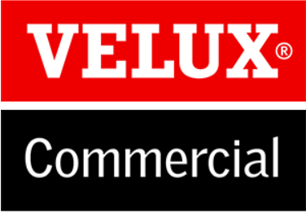
Inside Sales Manager

The VELUX Group is currently working on a strong business strategy focused on growth. As part of our growth agenda, we have recently established a new commercial division called VELUX Commercial.
VELUX Commercial designs and sells daylight solutions for commercial buildings such as offices, schools, healthcare institutions, airports, shopping centers and shops, large public buildings, train stations and industrial buildings.
We are currently looking for an Inside Sales Manager in Den Bosch, the Netherlands to support our commercial sales team at VELUX to help realize the plans and ambitions for growth.
Your challenges
- Management and development of the internal sales team (5 employees)
- Stimulate sales, build the pipeline of projects and build relationships with our customers.
- You are also part of the export team in Den Bosch, where you perform practical back-office tasks.
- As part of a global organization you can expect to travel roughly. 30 days a year - both in the Netherlands and internationally (usually Europe).

”This is a fantastic opportunity for a sales professional to support a newly established division that is focused on managing our growth strategy throughout the Netherlands. We need someone with a natural talent to bring a team together to deliver the right results quickly and get a kick out of being part of a dynamic and busy working environment, ”says Eric Gobes, commercial sales director at VELUX for the Benelux.

Your qualifications
- You have a Bachelor's degree in business, marketing or management A few years of experience in managing people.
- You have a hands-on mentality
- You like challenges
- You are a team player, an excellent communicator and you easily collaborate with people from different backgrounds - both internally and externally.
- We assume that you can communicate fluently in Dutch and have strong English and German language skills (both orally and in writing).

Your chances
The VELUX Group is the world leader in skylights and skylights. We are a family and foundation with a long history of strong results and we can offer exciting challenges and great opportunities to influence your own development. With us you get a unique opportunity to work with competent and dedicated colleagues where dedication, thoroughness and mutual respect are among our core values. We are a company where you can have a challenging job at a high level and still have a balance in your life and time for your family.
VELUX Commercial is characterized by an informal tone, a healthy sense of humor and we work as one team to achieve our ambitious goals. We believe in empowering people, and we support this by offering a high degree of freedom and investing in people who have the will and ability to make a difference.

Registration and contact
If you want to know more about this option and VELUX Commercial, please contact us on +31 226 366 151.
We look forward to your application and CV as soon as possible by e-mail: tvandervlugt@jet-bik.nl
Deadline for applications: November 22, 2019.
